How to edit an existing position:

- Log into coc.as.ucsb.edu
- Navigate to the dashboard (upper left corner)
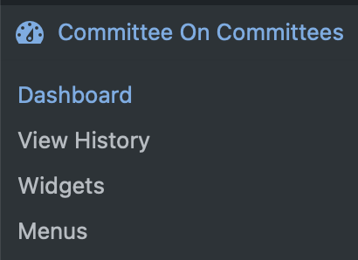
- Click on positions (left menu)
- Search positions (you can search the exact position name as in legal code or just search the BCU / organization)

To close positions:
- Hover over the position from search results and select quick edit
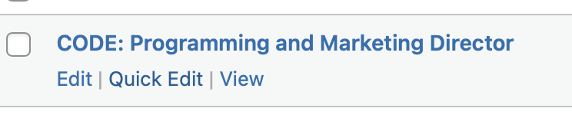
- Check private
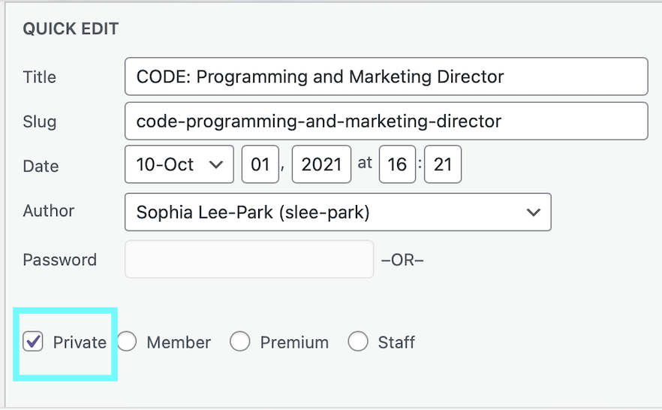
- Click update

To open positions:
- Hover over the position from search results and select edit

- Add the legal code (if not present or correct ) in the position description
  - AS Live Legal Code

- If CoC is hosting the application → add 1-2 interview questions specific to the position in the custom question boxes

- If there is an external application form, paste the link to the external apply URL field

- At the very bottom of the page, verify the length and openings are correct, and make sure hidden is not checked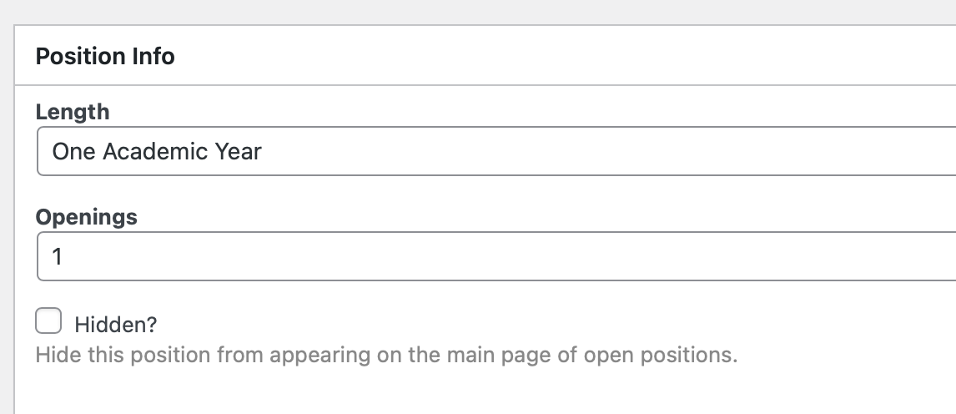
- On visibility, select edit and set to public.
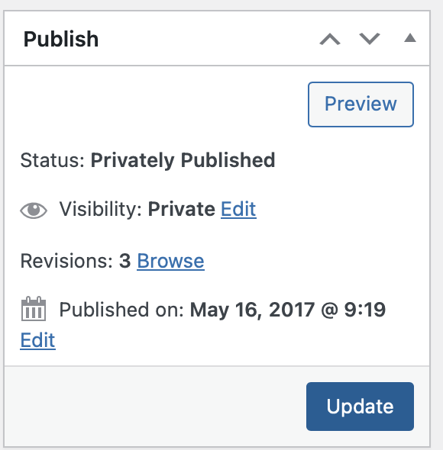

- Click update

- To verify the position was successfully added, you can check open positions
  - Note: if you are still logged in you will see more positions than are actually open because you can view the non public ones. If you want to see what anyone else would, you can log out and view positions.

How to create new positions
- If you are opening a position not already in the database, you’ll need to create a new position.
- Go to positions → add new position:


- For the position name, use the following format: “BCU name: position name”
  - For ex: TSA: Treasurer
  - Use the BCU name that is already in the system, for ex, all Transfer Student Alliance positions already in the website are listened as “TSA: etc”

- Paste the legal code for the position as it is in AS Live Legal Code
- Set the bottom fields as follows:
- 
- Select only the box of the BCU for the group:
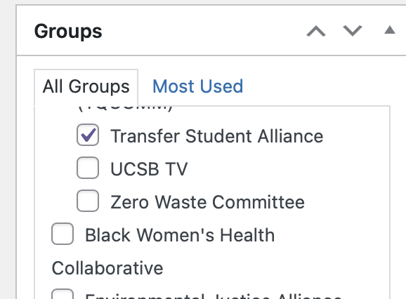

- Set the status from draft to approved and the visibility to public, then click publish.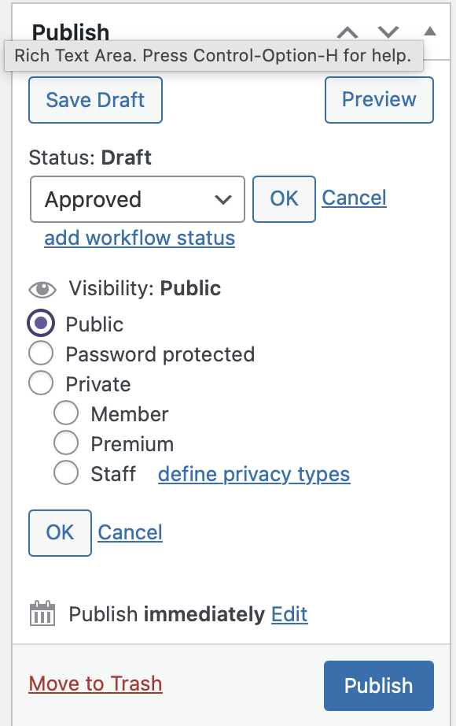

How to create or edit BCU groups

- If you need to create a group, just go to positions > groups > add new group
- Fill out all relevant info (parent group is Associated Students)
- To edit groups, search for them, select edit

